Boston, MA

LOCATION:
10 Causeway Street
Boston, MA 02222

HOTELS:

The hotels listed below participate in GSA’s government-wide lodging program, FedRooms® – which provides Federal Travel Regulation (FTR) compliant hotel rooms at or below per diem rates for federal government travelers while on official business.

You may find program information and a current list of all FedRooms® preferred properties at: http://www.fedrooms.com (a non-federal website). Also, per diem rates may be found at: http://www.gsa.gov/perdiem

FedRooms® Rates are available using all booking channels: TMC, E-Gov Travel Service, FedRooms® website, and hotel reservation centers.

You MUST ASK for the FedRooms® Rate (NOT the government rate) when you contact the hotels. FedRooms® properties are listed by proximity to the Boston location (closest to farthest).

CTRL + click on any highlighted property below to bring you to booking link:

Bulfinch 0.1 miles
107 Merrimac Street
Boston, MA 02114

Holiday Inn Boston at Beacon Hill 0.2 miles
5 Blossom Street
Boston, MA 02110
617-742-7630

Omni Parker House 0.4 miles
60 School Street
Boston, MA 02108

Royal Sonesta Hotel 0.5 miles
40 Edwin Land Boulevard
Cambridge, MA 02142

Millennium Bostonian 0.5 miles
26 North Street at Faneuil Hall
Boston, MN 02109

Club Quarters Boston 0.6 miles
161 Devonshire Street
Boston, MA 02110

Hyatt Regency Boston Financial District 0.7 miles
One Avenue de Lafayette
Boston, MA 02111

Hilton Boston Financial District 0.7 miles
89 Broad Street
Boston, MA 02110

Intercontinental Boston 0.8 miles
510 Atlantic Avenue
Boston, MA 02210

Hampton Inn Boston/Cambridge 0.9 miles
191 Monsignor O’Brien Highway
Cambridge, MA 02141

Doubletree Hotel Downtown Boston 1.0 miles
821 Washington Street
Boston, MA 02111

Boston Park Plaza Hotel & Towers 1.0 miles
50 Park Plaza at Arlington Street
Boston, MA 02116

The Westin Copley Place 1.2 miles
10 Huntington Avenue
Boston, MA 02116

Marriott Boston Copley Place 1.4 miles
110 Huntington Avenue
Boston, MA 02116

Westin Boston Waterfront 1.5 miles
425 Summer Street
Boston, MA 02110

Sheraton Boston 1.6 miles
39 Dalton Street
Boston, MA 02199

Hilton Boston Back Bay 1.6 miles
40 Dalton Street
Boston, MA 02115

Hyatt Boston Harborside 1.9 miles
101 Harborside Drive
Boston, MA 02128

Hilton Boston Logan Airport 2.1 miles
One Hotel Drive
Boston, MA 02128

Hyatt Regency Cambridge 2.2 miles
575 Memorial Drive
Cambridge, MA 02139

La Quinta Somerville 2.3 miles
23 Cummings Street
Somerville, MA 02145

Best Western Boston Inn at Longwood 2.8 miles
342 Longwood Avenue
Boston, MA 02115

Club by Doubletree Boston Bayside 2.9 miles
240 Mount Vernon Street
Boston, MA 02125

Comfort Inn 5.0 miles
900 Morrissey Boulevard
Boston, MA 02122

Red Roof Inn Boston Saugus 7.4 miles
920 Broadway (Route 1)
Saugus, MA 01906

If you have any further questions please feel free to contact us for immediate assistance at:
FedRooms GSA Lodging Program
Phone: 800-226-1741 Phone : 877-836-4859
Email: hotels@fedrooms.com Email : gsalodging@gsa.gov

Updated June 2008

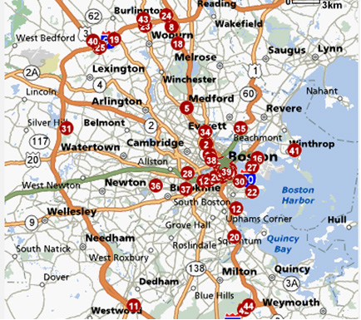

1 | Bulfinch
2 | Holiday Inn Boston/Somerville
3 | Holiday Inn Boston at Beacon Hill
4 | Radisson Hotel Boston
5 | Millennium Bostonian
6 | Sheraton Boston
7 | Club by Doubletree Boston Bayside
8 | Doubletree Hotel Downtown Boston
9 | Hampton Inn Boston/Cambridge
10 | Hilton Boston Back Bay
11 | Hilton Boston Logan Airport
12 | Hilton Boston Financial District
13 | Comfort Inn
14 | Marriott Boston Copley Place
15 | Red Roof Inn Boston – Woburn
16 | Boston Park Plaza Hotel & Towers
17 | Hyatt Boston Harborside
18 | Hyatt Regency Cambridge
19 | Intercontinental Boston
20 | Westin Boston Waterfront
21 | The Westin Copley Place
22 | Hyatt Regecy Boston Financial District
23 | Omni Parker House
24 | La Quinta Somerville
25 | Best Western Boston Inn at Longwood
26 | Royal Sonesta Hotel
27 | Club Quarters Boston
28 | Suburban Extended Stay

